press release no. 10

THE BEER&FOOD ATTRACTION & MIXOLOGY ATTRACTION 2026 LAYOUT
www.beerandfoodattraction.it
www.mixologyattraction.com/it

Rimini, 9th February 2026 – The Beer&Food Attraction & Mixology Attraction layout has been designed to offer operators an immediate overview of the exhibition areas and a smooth visitor experience throughout the entire Rimini Expo Centre. The event will be divided into 6 main exhibition sectors – Beer, Craft Beer, Mixology Attraction (new!), Food, International Horeca Meeting and BBTech Expo. These will be accompanied by the Innovation District, an area for start-ups and the out-of-home sector’s most innovative projects.
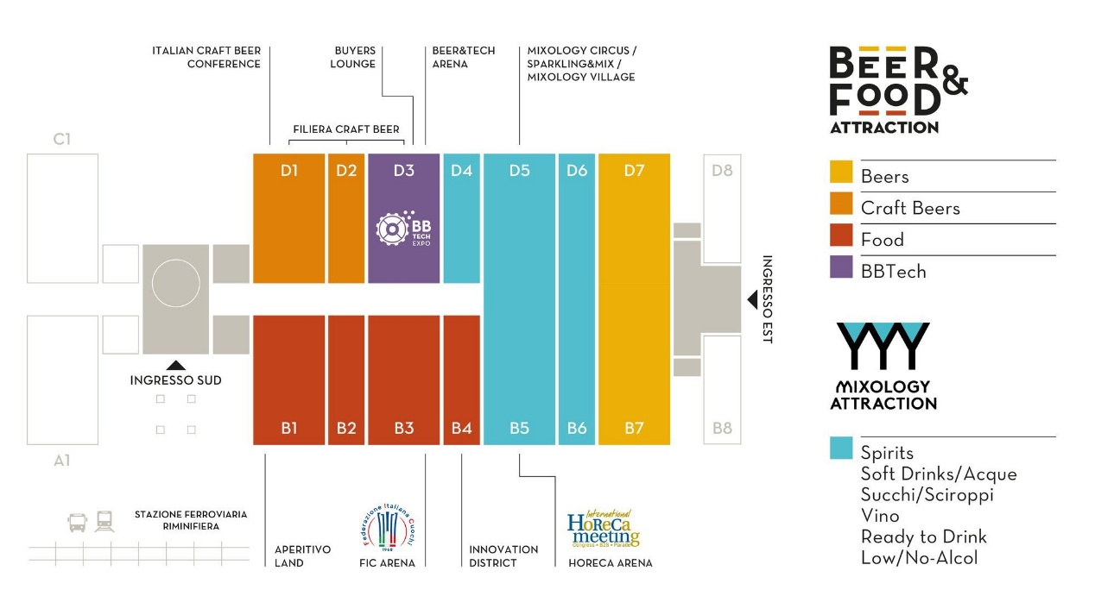
Entry to the show will be through the South and East Entrances, which lead directly to the heart of the exhibition itinerary.
FOOD
Entering from the South Entrance, visitors will encounter the Food area which, occupying halls B1, B2, B3 and B4, will be exhibiting a range of products for catering, casual dining and aperitifs. This section will also include Aperitivo Land (Hall B1), a special project designed to promote food and beverage combinations through a flexible exhibition format, enriched with demo areas and tasting opportunities.
Located in Hall B3, the FIC Arena will host the Italian Cuisine Championships organised by the Italian Chefs Federation, with over 500 competitors taking part in the various competitions. This area strengthens the link between gastronomic culture, professional training, and the Ho.re.ca. world.
INNOVATION DISTRICT
Hall B4 will host the Innovation District, created in partnership with ANGI (National Association of Young Innovators) and ITA (Italian Trade Agency), where businesses engaged in Research and Development will be located. The same Hall will also host the Start-Up Area with 16 young Italian and international companies selected in collaboration with ITA and ANGI, and the Lorenzo Cagnoni Awards for the most innovative solutions for the Out of Home sector.
MIXLOGY ATTRACTION (B5-B6-D4-D5)
Continuing along the route, halls B5 and B6 will host Mixology Attraction, the main new feature of the 2026 edition. This area will involve the world of bars and contemporary mixology. Here, spirits, soft drinks and waters, juices and syrups, wine, ready-to-drink beverages and low-alcohol and non-alcoholic options will provide a complete overview of the latest trends in mixed drinks. This section will also include the Horeca Arena (Hall B5), where the 15th edition of the International Horeca Meeting will be holding its programme of talks and workshops on trend analysis, market scenarios and the sector’s future opportunities.
The exhibition will continue in halls D4 and D5, where Mixology Attraction will be further developed. To be more precise, hall D5 will host Mixology Circus, an arena for the world of spirits and signature cocktails, alongside Mixology Village, an area for companies that promote premium labels and professional bartending equipment. Mixology Attraction will also include the Sparkling&Mix area for wineries with mixology proposals.
BEERS AND CRAFT BEERS
Halls D1, D2 and D3 will showcase the entire craft beer supply chain, from raw materials (malts and hops) to production and bottling technologies, right through to the finished product with leading independent breweries and specialist suppliers in attendance. An itinerary that offers a comprehensive overview of the craft beer world, from research to production.
Hall D3 will be the home of BBTech Expo and its solutions and systems for beverage production, packaging and distribution, as well as the Beer&Tech Arena, a reference point for talks, workshops and in-depth discussions on innovation and technologies for the beverage industry.
Halls D7 and B7 will house the beer sector with medium and large breweries in attendance, completing the event’s exhibition offer for the beer industry and providing a comprehensive representation of national and international brewing excellence. A wide and high-quality offer that will see Italy’s leading players, and a significant number of foreign brands, presenting their products both directly and through top importers.

PRESS CONTACT ITALIAN EXHIBITION GROUP:
Head of media relation & corporate communication: Elisabetta Vitali; press office manager: Marco Forcellini, Pierfrancesco Bellini; press office coordinator: Luca Paganin; international press office coordinator: Silvia Giorgi; press office specialist: Nicoletta Evangelisti, Mirko Malgieri; media@iegexpo.it
MEDIA AGENCY BEER&FOOD ATTRACTION - BBTECH EXPO:
Mind the Pop - Martina Vacca: martina@mindthepop.it, mob. +39 339 748 5994; Fabrizio Raimondi: fabrizio@mindthepop.it, mob. +39 335 389 848; Stefano Chiossi: stefano@mindthepop.it, mob. + 39 388 739 4358.

