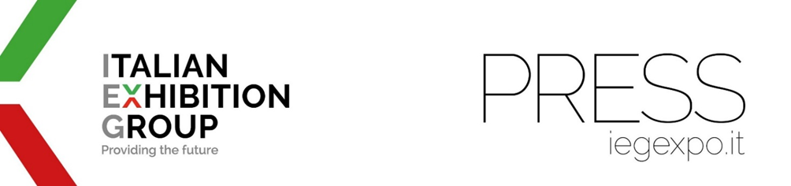
Press release
ILARIA CICERO IS THE NEW GLOBAL EXHIBITION DIRECTOR
OF ITALIAN EXHIBITION GROUP’S FOOD & BEVERAGE DIVISION

- Cicero will lead SIGEP WORLD, BEER & FOOD ATTRACTION, BB TECH EXPO, MIXOLOGY ATTRACTION, and the Group's abroad food-related trade shows.

Rimini, March 13, 2026 – IEG – ITALIAN EXHIBITION GROUP is focusing on outstanding professionalism for the Italian and international development of a key area of ​​its business: food & beverage.
Ilaria Cicero is the new global exhibition director of IEG's Food & Beverage Division, which includes the great SIGEP WORLD—which showcases the excellence of artisan gelato, pastry, bakery, pizza, and coffee worldwide—, BEER & FOOD ATTRACTION, BB TECH EXPO, MIXOLOGY ATTRACTION, and the international food-related events in Asia and the United States.

In addition to this new role, she will continue to serve as Chief Executive Officer of IEG Asia in Singapore. Ilaria Cicero holds a law degree and a Ph.D. in European Community Law, an LL.M. from the University of London, and several specialized master's degrees. Prior to leading IEG Asia, she served as Group General Counsel, M&A Executive Director, and Head of the Corporate & International Development Division of the Fiera Milano Group. In the trade fair and conference sector, she has also gained experience in areas such as Food & Beverage, Hospitality, Lifestyle, Retail, Oil & Gas, and Interior & Design.

Throughout her career, Cicero has led successful transactions, acquiring expertise in areas such as M&A, Venture Capital, IPOs, and closing joint venture agreements not only in Italy, but also in Germany, France, the United States, Brazil, Turkey, the Middle East, Russia, China, India, Thailand, Malaysia, and Singapore.
Before entering the Trade fairs industry, she worked at a US law firm, handling projects involving private equity funds.

PRESS CONTACT ITALIAN EXHIBITION GROUP | media@iegexpo.it
head of corporate communication & media relation: Elisabetta Vitali| press office manager: Marco Forcellini, Pier Francesco Bellini | international press office coordinator: Silvia Giorgi | press office coordinator: Luca Paganin | press office specialist: Nicoletta Evangelisti, Mirko Malgieri

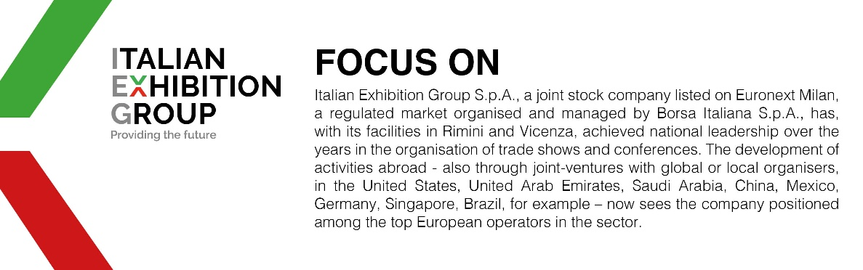

This press release contains forecast elements and estimates that reflect the management’s current opinions (“forward-looking statements”), particularly regarding future management performance, realization of investments, cash flow trends and the evolution of the financial structure. For their very nature, forward-looking statements have a component of risk and uncertainty, as they depend on the occurrence of future events. The effective results may differ (even significantly) from those announced, due to numerous factors, including, only by way of example: food service market and tourist flow trends in Italy, gold and jewellery market trends, green economy market trends; the evolution of raw material prices; general macroeconomic conditions; geopolitical factors and evolutions in the legislative framework. Moreover, the information contained in this release does not claim to be complete and has not been verified by independent third parties. Forecasts, estimates and objectives contained herein are based on the information available to the Company as at the date of this release.

